Wilderness/Promise #3 Pastor Rick Baker
November 14 2021
The Battle for You:
Learning How to Confront and Combat Satanic Opportunism
(Luke 4:1-13)
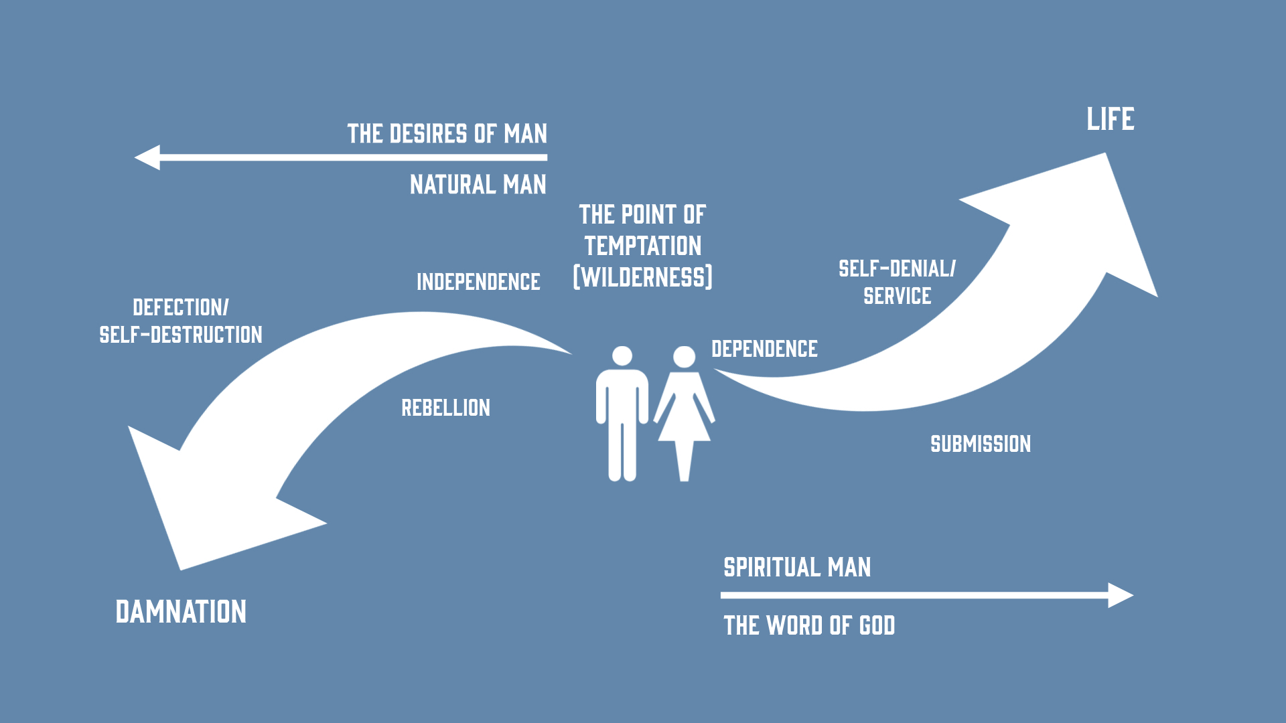

Satan’s familiar playbook – to keep you from trusting and obeying God through slick persuasion—the circumstances he finds most opportunistic are times of suffering deprivation—health, resources, losses.
The more loosely you hold the things of this world, the less likely you are to be tempted by Satan’s strategy—what we hear from Paul (Phil. 3:8) and witness in Jesus.

- Garden temptation of Adam and Eve
- 3 failed events of Israel in the wilderness
- Gave into their cravings Ex. 16:1-3; Num. 11:1-6
- Made a golden calf and worshiped it Ex. 32:1-15
- Tested/rebelled against the Spirit of God Ex. 17:1-7; Num. 20:1-13

God’s champion led by the Spirit to be tempted by Satan—a showdown—where the first Adam failed, the second must not... Wilderness refines, refutes, reveals—how wilderness makes or breaks you... Don’t be ignorant...

Temptations—Shortcuts based on dissatisfaction and the appeal to self to subvert our loyalty to Christ

- The subtle or not so subtle questioning of God’s provision and care—the temptation to trade dependence on the Spirit for the independent replacement of the physical/material (Lk. 4:3-4).

“If (SINCE) you are the Son of God!”
The temptation to hear the voices (ministries) shouting at us in our need...you’re a child of God; He should be treating you like it—you’re the child of a King—you shouldn’t be doing without—you should have the best of everything!

Life is not defined by physical provision but by God’s will and depending on His lead. (Deut. 8:3

- The offer to trade the hard mission of suffering for a get prosperous and quick offer of power and importance—the temptation to trade loyalty to God (Christ) for loyalty to other gods (Lk. 4:5-8).
“I (Satan) will give you...” I have an offer to shortcut the hard work and suffering that the Father has mapped out for you.”
The temptation to get it quick and easy—the prize and the power and none of the pain!—“if you worship me, it will all be yours!”

Any offer that requires you to trade your worship of God for anyone or anything is any empty promise that will lead to slavery and utter destruction. You’re hitching the wagon of your life to an unstoppable caravan to oblivion (Deut. 6:13).

- The poisoning of a promise(s) to undermine your faith in God—the temptation to use the promises of God to further the sovereignty of our own independent will...rather than God remaining rightfully sovereign over the enacting of his promises for our good and his glory (Lk. 4:9-12)

“If (SINCE) you are the Son of God”...demonstrate that God can really be trusted.
The temptation to prop up our sagging faith by always testing God to see if what he says is true—living in doubt, rather than faith. Trusting in God only if you can constantly see great examples of his miraculous power (Matt. 16:4—a wicked and adulterous generation demands a sign..., not one living by faith)

Life is about trusting God and not testing Him otherwise we are actually trading in our faith in God for sovereignty over Him. (Deut. 6:16). I believe Jesus is saying that He will not be our conditional God legitimized by His willingness to entertain our sovereign plans for Him—even if we are forcing Him to act on His promises.

Satan left until an opportune time... tired, lonely, hurting, stressed, afraid, pressured, forsaken, mistreated, canceled

